Chemistry 20

Lesson 13 – Intermolecular Forces

Intermolecular Vs Intramolecular Forces
The Kinetic Molecular Theory of gases, which we will study in a later unit, describes the behaviour of gases in terms of the motion of gas molecules. One of the assumptions of the Kinetic Molecular Theory of gases is that there are no attractive forces between the gas molecules. The gas molecules collide and bounce off of each other, but there are no attractive or repulsive forces between the molecules.

In 1873 a Dutch physicist, J. D. van der Waals, empirically challenged this assumption. Van der Waals gathered evidence concerning deviations from the “ideal” behaviour of gases to suggest that there were intermolecular forces – i.e. forces between molecules. His evidence demonstrated that there are attractions between molecules and that the difference in intermolecular forces results in different melting and boiling points for different molecular substances. The greater the intermolecular force, the higher the boiling and melting point.

Intermolecular forces should not be confused with intramolecular forces. Intramolecular forces are the forces that hold atoms together within molecules. Intermolecular forces are the forces that exist between molecules. For example, chlorine has intermolecular forces between Cl₂ molecules, while the intramolecular forces between Cl atoms hold the individual molecules together.
Cl
Cl
Cl
Cl
Intramolecular force (bonding forces within molecules)
Intermolecular forces (forces between molecules)
Intramolecular force

There are two main types of intermolecular forces between molecules:
1. van der Waals forces
a. dipole-dipole forces
b. London dispersion forces
2. hydrogen bonding
It is believed that in most cases there are several types of intermolecular forces acting together to produce the total attraction between molecules.

Van der Waals forces
Van der Waals forces are believed to be present between all chemical species – atoms, molecules and ions. Van der Waal forces are subdivided into dipole-dipole forces and London dispersion forces.

Dipole-Dipole Forces
If the molecules in a sample are polar, the positive end of one molecule is attracted to the negative end of a neighbouring molecule, which attract the next, and so on. Note in the figure below that the central polar molecules are simultaneously attracted to all of the polar molecules surrounding it.
δ⁺ δ–
δ⁺ δ–
δ⁺ δ–
δ⁺ δ–
δ⁺ δ–
δ⁺ δ–
δ– δ⁺
δ– δ⁺
δ⁺ δ–
δ– δ⁺
δ– δ⁺
δ– δ⁺
δ⁺ δ–
δ⁺ δ–
δ⁺ δ–

London Dispersion Forces
Many substances like CO₂, H₂, and Cl₂ consist of non-polar molecules and yet each of these substances has its own boiling point. Therefore, there must be a force of attraction which does not depend on polarity. Consider the case of chlorine which condenses from vapour to liquid when cooled to –35ºC and solidifies at –101ºC. The two chlorine atoms in each chlorine molecule share two bonding electrons resulting in a strong covalent bond.
Cl
Cl
Cl
Cl
Covalent bond
London dispersion intermolecular forces

Now consider that the protons within the chlorine nuclei in one molecule attract all of the other electrons in neighbouring molecules. All electrons in one molecule are thus simultaneously attracted by all neighbouring nuclei. Because these electrons are much farther away than the valence energy level, they are not attracted very strongly by these nuclei. However, if the chlorine molecules are moving slowly enough these attractions will pull the molecules together (i.e., cause condensation).

Two factors influence the strength of London dispersion forces.
1 . The number of electrons in the molecules. In general, the more electrons the molecules of a substance have, the stronger the London dispersion forces.
2. The shapes and sizes of the molecules. Shape and size affects how closely the molecules may approach each other in solid and liquid states. The closer the molecules can get, the stronger the attraction will be.
London dispersion forces (intermolecular) are much weaker than covalent bonds (intramolecular) for two reasons. First, the simultaneously attracted electrons are much further from the nuclei and, second, repulsion or shielding effects from inner electrons are significant.

A fairly good measure of the comparative strengths of intermolecular forces for substances is a comparison of their boiling points. This works fairly well since the stronger the intermolecular forces holding the molecules together in liquid phase, the more heat will be required to cause them to separate to enter the gas phase. The following table compares the boiling points of the noble gases to the number of electrons they have.

Boiling Point Vs Number of electrons (Noble gases)
Element | # of e– | boiling point (ºC)
He  Ne  Ar  Kr  Xr  Rn | 2  10  18  36  54  86 | –269  –246  –186  –152  –107  –62

London dispersion forces are far stronger than dipole-dipole forces. All molecules have London dispersion forces and, if they are polar, they also have dipole-dipole forces. However, if two types of molecules have similar London dispersion forces (i.e., they have the same number of electrons per molecule) and one type is polar and the other is non-polar, the polar substance will tend to have a higher boiling point due to the extra dipole-dipole force.

For example, when we compare the intermolecular forces of fluorine (F₂) and hydrogen chloride (HCl) we would reason as follows: Fluorine and hydrogen chloride are isoelectronic (i.e., they have the same number of electrons) with 18 electrons each. (For fluorine: 2 × 9 = 18 and for hydrogen chloride 1 + 17 = 18.) We would expect fluorine and hydrogen chloride to have similar London dispersion forces and therefore similar boiling points. However, since hydrogen chloride is polar and fluorine is non-polar, hydrogen chloride also has dipole-dipole forces. Therefore we would expect that hydrogen chloride would have a higher boiling point than fluorine. When we measure the boiling points of each compound we find that hydrogen chloride boils at –83.7 ºC and fluorine boils at –188 ºC.
F
F
H
Cl

Limitations of Van der Waal Forces – hydrogen bonding
The previous section on intermolecular forces emphasised that these forces increase with increasing number of electrons in an atom or molecule. Try to predict the boiling point for HF by examining the data in the table below.

Boiling Point of Hydrogen Halides
Hydrogen halide | # of e– | B. P. (ºC)
HF  HCl  HBr  HI | 10  18  36  54 | –83.7  –67.0  –35.4

The four compounds in the table are similar in that they are hydrogen halides. The generalisation about increasing van der Waals forces with increasing number of electrons holds up when HCl, HBr and HI are compared. But HF does not fit into the predicted trend. Instead of having a boiling point lower than –83.7 ºC, thus fitting into the trend, HF has the highest boiling point of all four compounds, +19.4 ºC. Examination of the electronegativities of the halogens reveals that the HF molecule is the most polar. However, molecular polarity alone could not account for the magnitude of reversal in trend. This suggests the existence of an additional intermolecular force, which is greater than van der Waals forces. This additional force is hydrogen bonding.

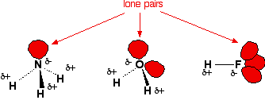
Hydrogen bonding arises when a molecule contains a highly polar bond, such as an
O–H, F – H or N – H bond, the positive end of which is hydrogen. When a hydrogen atom is bonded to an atom of high electronegativity (F, O, N and less commonly Cl) charge separation along the bond is great enough that the hydrogen atom is effectively left “naked” without an electron. Consequently, the hydrogen atom's positively charged nucleus can interact easily with lone pairs of electrons on other neighbouring molecules.

The + hydrogen is so strongly attracted to – lone pairs that it is almost as if you were beginning to form a covalent bond. It doesn't go that far, but the attraction is significantly stronger than an ordinary dipole-dipole interaction. Hydrogen bonds have about a tenth of the strength of an average covalent bond. London dispersion forces are weaker than hydrogen bonding and dipole-dipole forces are the weakest intermolecular force.

Properties of Hydrogen Bonded substances
Hydrogen bonding affects physical and chemical properties in various ways. Some of these effects include:
1. Increased melting and boiling points. For example, H₂O is a liquid at room temperature which boils at 100 ºC, whereas H₂S, which has more electrons, is a gas at room temperature and boils at –61 ºC.
2. Increased solubility between substances involving hydrogen bonding. For example, water, H₂O, and methanol, CH₃OH, or ethanol, C₂H₅OH, are soluble in each other in all proportions. All three compounds exhibit hydrogen bonding.
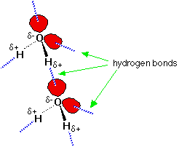
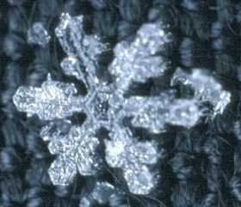
3. Shape and stability of certain chemical structures. For example, the expansion of liquid water upon freezing is a result of hydrogen bonding between molecules which creates hexagonal holes in the crystal structure. The resulting structure is less dense than water. The structure results in the hexagonal shapes of snow flakes.
Hydrogen bonding also has significant effects upon protein molecules and DNA. The behaviour and stability of protein molecules and DNA is related to their shape, which in turn is related to the hydrogen bonding present.

Assignment
1. Using the data from the Boiling Point Vs Number of electrons (Noble gases) table, plot a graph of boiling point versus number of electrons for the noble gases.

2. State a generalisation relating London dispersion forces to the number of electrons in atoms or molecules. Explain the generalisation in terms of Ar, boiling point
–186 ºC, and F₂, boiling point –188 ºC.

3. Both Kr (boiling point, –152 ºC) and HBr (boiling point, –67 ºC) are isoelectronic (have the same number of electrons). Explain what factors could affect intermolecular bonding to cause the difference in boiling points between Kr and HBr.

4. The boiling point of Cl₂ is –35 ºC and the boiling point of C₂H₅Cl (monochloroethane) is 13 ºC. Does the explanation proposed for Question 3 apply here? Explain.

Refer to the following graphs to answer questions 5, 6 and 7 below.

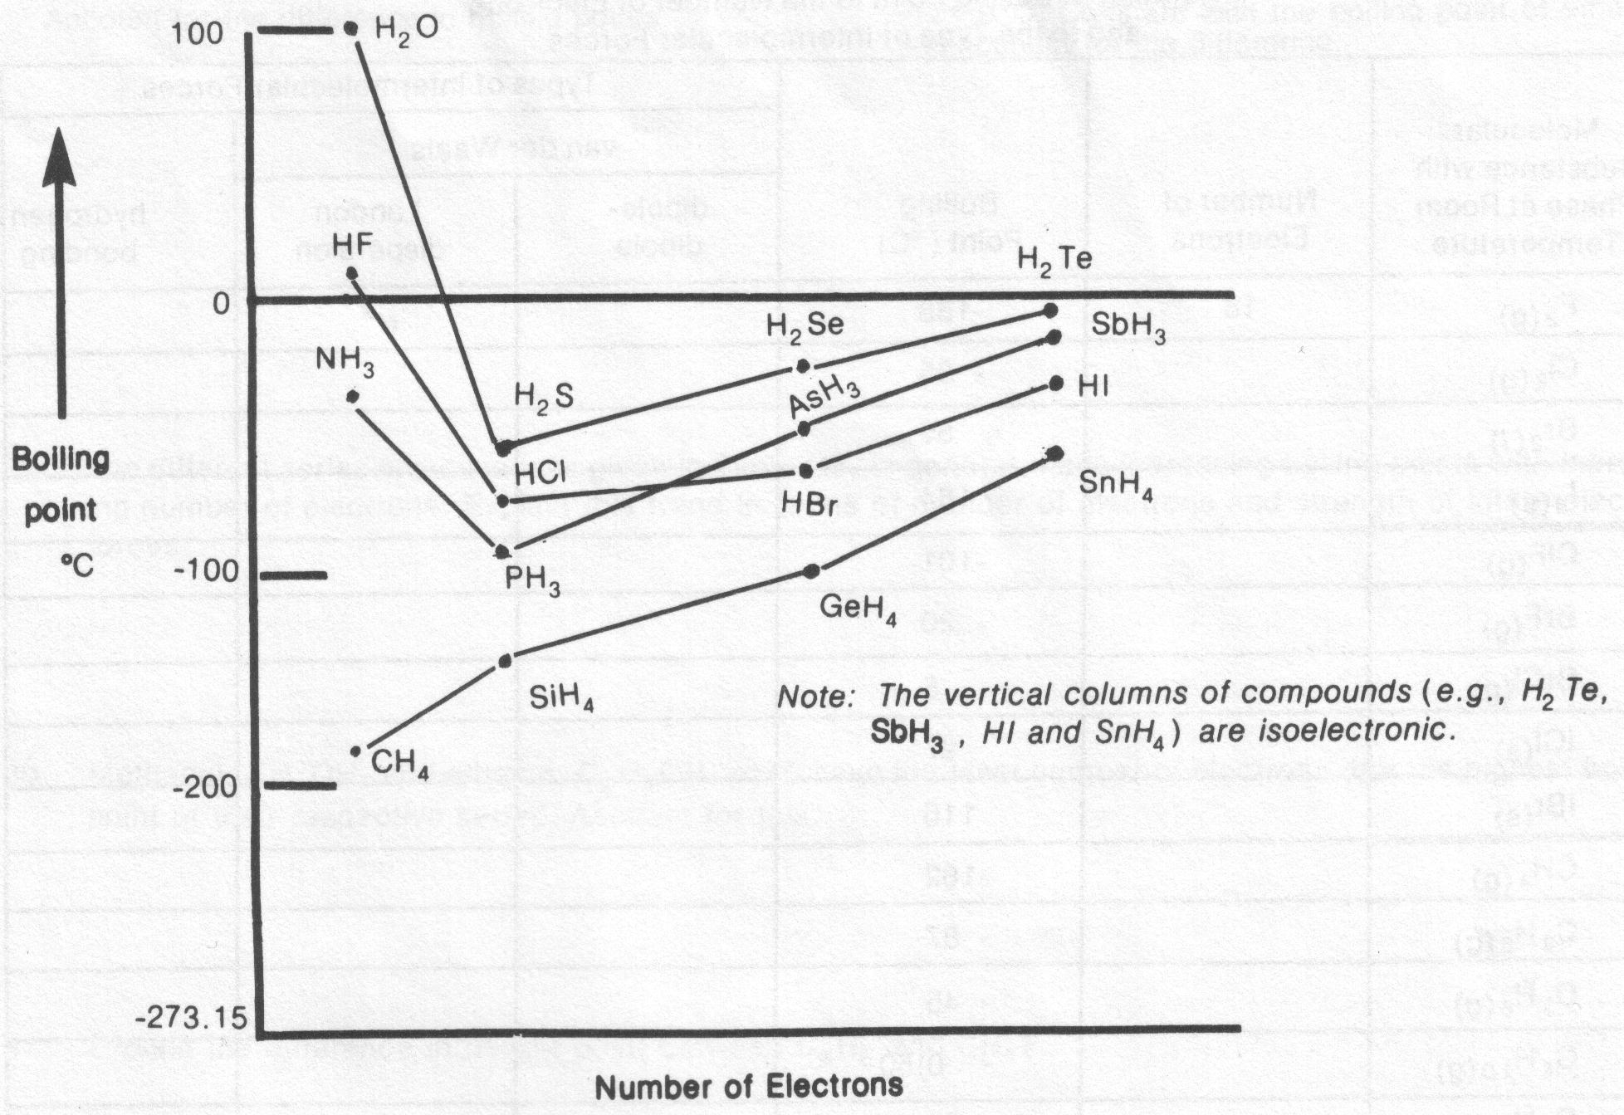

5. The hydrogen compounds of Groups VA, VIA and VIIA elements have consistently increasing van der Waals forces (except for the first hydrogen compounds) with increasing number of electrons. Explain why the boiling point of the first hydrogen compounds of Groups VA, VIA and VIIA elements display a reversal in trend.

6. Explain why CH₄, the first member of the Group IVA hydrogen compounds, does not show the reversal in trend displayed by the first hydrogen compound of the other elements.

7. The boiling points of the hydrogen compounds of the Group IVA elements are consistently lower than the boiling points of the other hydrogen compounds. Give a reason for this effect.

Complete the following table. The first is given as an example. Note that there are six series or groups of molecules.

Molecular substance with phase at room temperature | Number of Electrons | Boiling Point (ºC) | Types of Intermolecular Forces
 |  |  | van der Waals |  | hydrogen bonding
 |  |  | dipole-dipole | London disp.
e.g. – F_{2 (g)} | 18 | –188 |  | √
Cl_{2 (g)} |  | –35
Br_{2 (l)} |  | 59
I_{2 (s)} |  | 184
ClF_{(g)} |  | –101
BrF_{(g)} |  | –20
BrCl_{(g)} |  | 5
ICl _{(s)} |  | 97
IBr_{(s)} |  | 116
CH_{4 (g)} |  | –162
C₂H_{6 (g)} |  | –87
C₃H_{8 (g)} |  | –45
C₄H_{10 (g)} |  | –0.50
C₅H_{12 (l)} |  | 36
CF_{4 (g)} |  | –129
CCl_{4 (l)} |  | 77
CBr_{4 (s)} |  | 189
CH₃F _{(g)} |  | –78
CH₃Cl _{(g)} |  | –24
CH₃Br _{(g)} |  | 3.6
CH₃I _{(l)} |  | 43
CH₃OH _{(l)} |  | 65
C₂H₅F _{(g)} |  | –38
C₂H₅Cl _{(g)} |  | 13
C₂H₅Br _{(l)} |  | 38
C₂H₅I _{(l)} |  | 72
C₂H₅OH _{(l)} |  | 78

Use the preceding table to answer Questions 8 to 14.

8. Compare the boiling points of BrF_{(g)} and C₃H₈ _{(g)}. Account for the difference in boiling points.

9. Dimethyl ether, CH₃OCH_{3(g)}, has a boiling point of –24.9 ºC. Compare with the boiling point of ethanol, C₂H₅OH, and account for the difference.

10. The different series of substances given in the table, in general, have increasing boiling points with increasing number of electrons. Explain this trend in terms of number of electrons and strength of intermolecular forces.

11. Methanol, CH₃OH, and ethanol, C₂H₅OH, each have the least number of electrons but the highest boiling point of their respective series. Account for this.

12. Explain the difference in boiling point between C₂H₆ and CH₃F.

13. Explain the difference in boiling point between Cl₂ and C₄H₁₀.

14. Explain the difference in boiling point between BrCl and C₂H₅Br.

